Howden Equestrian Centre

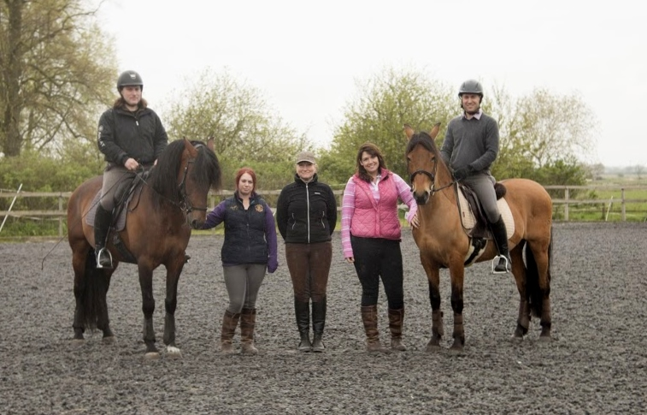
Client Information Pack
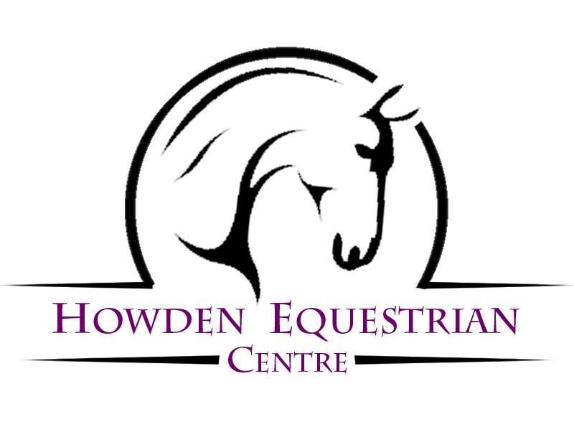

Welcome to Howden Equestrian Centre!
H.E.C. is a small family run riding school, based between Howden and Holme-on-Spaldingmoor. We are fully licensed with East Riding of Yorkshire Council, insured with SEIB equestrian insurance and we are a BHS Approved riding centre, and Pony Club Centre.
All of our staff are experienced instructors, with collectively over 70+ years in the training of horse and rider. We are all horse owners, and train and compete in our free time. We also all have the relevant qualifications to go with our years of teaching experience.
As a BHS approved centre, we undergo a vigorous yearly inspection, ensuring high standards are adhered to in all aspects of riding school management, including quality of instruction, animal welfare etc.
We run a little differently to your average riding school, in that, as a family run school, all our instructors are in house, ensuring we can keep the high standards we strive to achieve in every lesson. We will not offer the typical big group “ride to the rear of the ride” type lessons, as we prefer to work on the one-on- one, small group type lessons, meaning our rider’s progression is clear. We ourselves never stop learning and attend further training sessions (Professional CPD) several times a year.
Furthermore, with our newest addition “Hec-tor” the Racewood riding simulator, we are able to offer posture & position analysis to a wide variety of riders, from first time riders to seasoned competitors!
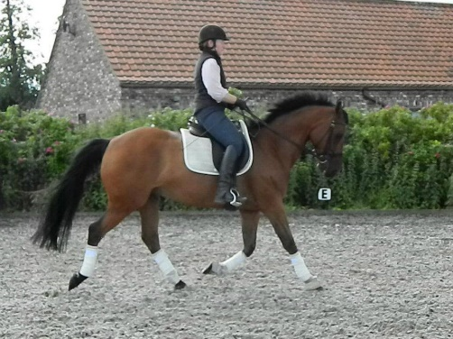
Meet the team:
Janice Chadwick, BHSAI & (Level 4 Senior Coach), BHS Accredited Professional Coach (APC) - (Instructor)
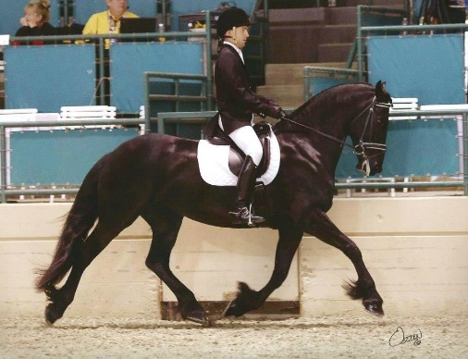
Andrew Chadwick,
BHS Stage 3 Coach
National Diploma in Equitation - (Instructor)

Jenna Whitaker, BHS Level 4 Senior Groom & UKCC I (Sports Coach - Riding) - (Yard Manager)

Your lesson –
The first lesson is often a special “assessment” lesson which is a 30min lesson, where we will assess a new customer’s level, ability, balance, and suitability to different horses.
- You will receive a welcome pack. These will enclose any up-to-date rules and the rider registration forms required for your first lesson.
- Please arrive 5 mins early for your first lesson. Riding hats can either be hired for a £5 per use hat hire fee, or you can use your own. Please check your hat is up to current safety standard. These standards will be enclosed in your welcome pack.
- If you are under 18 an adult will need to sign the rider registration forms.
- When arriving for your first lesson, please come through the wooden gates and park in the car park to the right-hand side. Please make your way down past the arena to the barn where yard staff will be waiting to help.
- Please DO NOT RUN when anywhere on the yard, horses can be scared by sudden movement.
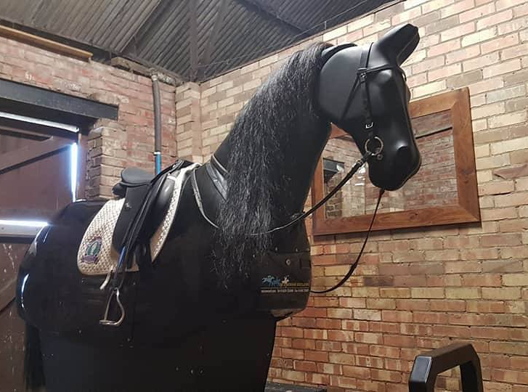
After your first lesson, we will discuss a tailored plan forward, with recommendations for the future. Prices for lessons are as follows:
- Private 30min lesson weekday afternoons £25
- Private 30min lesson evenings & weekends £30
- Semi private 30min lesson (2 riders) £23
- Children’s group lesson 30min (3 riders) £19
- Children’s group lesson 30mins (4-5 riders) £16

For all future lessons, please arrive 5 mins early ready to ride, as any delay getting hats / body protectors / coats etc. on will affect lesson times during the day. If you are borrowing one of our hats there is an additional hat hire fee of £5 per use. We recommend all customers purchase their own hat as soon as possible. PLEASE DO NOT ENTER THE STABLE YARD.
There are benches, and cold drinks/snack vending machine available in the barn for your convenience however we ask that parents do not leave children unattended on the yard, remembering to be considerate of other riders.

What to wear?
Please wear suitable clothing, it is ok to not own specific horse-riding clothes, however, skirts, shorts, ugg boots etc are not suitable. Please wear jeans / leggings, jumpers, and coats, with strong sturdy footwear. Boots or wellies with a small heel are acceptable, trainers are not allowed. Please remember, although we do have a covered arena, it is often cold and can suddenly rain, so please do remember coats and gloves as riding is an outdoor sport!
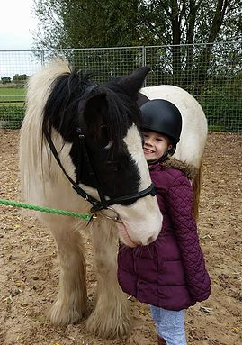
Yard Rules:
- Children are not to be left unattended at any time on the yard.
- No running, shouting on the yard at any time, horses can get scared
- Do not run or jog past any riding arenas
- Please leave all gates as you find them, this is for your and the horses safety.
- Do not park outside the main gates, please come inside, and park in the car park to the right.
- Do not feed the horses treats, without permission as this encourages them to bite.
- No entry into stables/arenas/fields without permission
- Horses are unpredictable, they might get scared, kick or bite
- Please follow sign instructions, no entry areas / no climbing signs are to be followed
- Do not climb on fences / bales it is dangerous for you, and other people
- Follow instructions of yard staff at all times
- Arrive 5 mins early for all lessons, and please be ready to ride on time, as spending time putting on hats / jumpers etc holds up lessons and affects the whole day.
- We do have a cancellation policy please see our T&C’s
- All riding hats must be up to current BHS standards (these are in your welcome pack).
- All lessons / Pony Club sessions must be booked in advance
Opening hours:
Monday, Thursday & Friday 12pm – 7pm, Saturday 9am-5pm
Closed Tuesday, Wednesday & Sunday.
Contact details:
07562393494
howdenequestrian@gmail.com
Terms and conditions
- ALL Clients:
  - Must have completed a Rider Registration Form before riding a horse. This will be countersigned after the lesson by an instructor.
  - Must resubmit their Rider Registration Form if their details change. (The responsibility falls to the Parent/Guardian if the child is under 18).
  - We reserve the right to refuse you to ride a particular horse/pony if we feel that the safety of the rider or horse is in question. (Or that the horse is not available at this time).
  - You reserve the right to change to another horse/ pony, providing one is available, and it is practical and safe to do so.
  - You also have the right to request another Instructor subject to availability.
- Punctuality and Arrival Times:
  - Please arrive 5 minutes before the start of the lesson to allow time for hat fitting.
  - If you are late, we unfortunately cannot make that time up as other clients will be waiting for their lessons to start on time.
  - If we are running late for whatever reason we will make up your lesson time
- New Clients:
  - Are required to attend an assessment lesson before being allowed join an existing group. This allows us to ascertain your riding level.
  - All Clients Rules Apply.
- Payments:
  - If you fail to turn up, you will be required to pay in full.
  - All payments to be made 24 hours BEFORE a lesson takes place.
  - Any payment received more than 24 hours AFTER lesson, will be subject to a £5 per person / per week late payment charge.
- Cancellations:
  - 48 hours’ notice MUST be given for any cancellations
  - If less than 48 hours’ notice is given, the lesson will be charged for at the full rate
- Instructors:
  - Instructors reserve the right to refuse to teach a client for any reason.
- Bad Weather or Conditions:
  - Activities might be cancelled in extreme weather.
  - You should call us on 07562393494 before you leave for the centre if the weather is in doubt. If we have not contacted you, please do not assume the lesson is cancelled, often it is not as bad here as it might be elsewhere. We will contact you to cancel in the case of extreme weather.
  - We reserve the right to cancel riding because of bad weather at any time.
  - Lessons will run as normal unless you are contacted.
  - An alternative session such as Stable Management may be offered.
- Safety Equipment and Riding Wear:
  - P.P.E (Personal Protective Equipment): Every time you handle a horse you are required to wear the appropriate Personal Protective Equipment.
  - Riding Helmets:
    - Hats (all types): Should be up to current BHS riding standards
    - Must be worn and fastened at all times while riding a horse.
    - Must be worn and fastened at all times while handling or a horse.
    - We strongly advise all customers to purchase their own helmet as soon as possible.
      - We recommend against purchasing second hand riding helmets in case they have been damaged.
      - We reserve the right to refuse you lessons if hat is not up to standard
    - We reserve the right to charge customers for helmet hire.
      - Cost per Session is £5.
  - Body Protectors:
  - We do not provide body protectors, nor can we fit one, we are not qualified fitters
  - Use of body Protectors is a choice which is down to parent’s discretion.
  - All body protectors used should display a BETA Safety Tag (2009/2018).
  - Riding Footwear:
    - Clients must wear appropriate footwear while riding.
    - Allowed Footwear:
      - Jodphur Boots
      - Riding Boots
      - Wellies with a small heel
      - Most boots with a small heel
    - Disallowed Footwear:
      - Trainers
      - High Heels
      - Sandals
      - Flipflops
      - We reserve the right to refuse footwear we deem unsafe.
    - We recommend toe protection whenever handling a horse.
  - Jewelry:
    - You should not wear Jewelry of any kind, anything you wear you do so at your own risk.
    - It's the parents responsibility to check their child isn't wearing Jewelry.
- Extra Visitors and/or Friends of the Family:
  - Children must be supervised at all times by a legally responsible person.
  - Parents are advised not to leave your children unattended at any time during their stay
  - If spectating, please remain as quiet as possible, and in full view of the horses/ponies & Instructor at all times.
  - Whilst spectating, the instructor reserves the right to ask you to leave the arena area if they feel the safety of the rider or horse/pony is in question.
  - Young Children: Must be supervised at all times by a responsible person and remain seated and quiet whilst lessons are in progress and not to run around. No climbing or sitting on fences is allowed.
  - No running / shouting / jumping etc on the yard at any point. Please do not run.
- Movement of Horses & ponies and Farm Equipment around the yard and surrounding areas is unavoidable and we ask you to give way to them at all times.
- Out of Bounds:
  - There are No Entry Type signs and notices posted around the facility, you must acknowledge and obey them, ignoring them is at your own risk.
  - The stable yard is no entry unless under direct supervision by staff.
- Warning Signs: We have many different warning signs on the yard, they are there for a reason, you must obey them. We reserve the right to ask you to leave at any time if we think you are a danger to yourself or others.
- Smoking Policy: We have a Strict No Smoking Policy anywhere on the premises, if you are caught you will be asked to leave.
- Pets: We don't allow any clients to bring their own pets onto the grounds/premises.
  - Guide Dogs are allowed by prior arrangement only.
- Horses/Ponies: All animals are unpredictable, Do Not Feed the Horses & Ponies at any time. Do not enter any field, box or make contact with a Horse or Pony at any time, without prior authorisation from a member of Management
- Cars, Bicycles: We can't be held responsible for any damage to your transportation while on the premises/grounds. All vehicles are parked at your own risk.
- Personal Property: We can't be held responsible for Damage, Theft or Loss of your personal property while it's on the premises.
- OTHER:
  - Parking is not permitted outside the gateway / blocking neighboring gateways.
  - The drive is not a footpath and walkers are advised to take extreme care due to the uneven surface.
  - There is a possibility of sudden ice on the path in winter. Please walk carefully. Walk on the grass if ice is suspected.
  - Maximum Speed on the premises / private driveway is 10 mph. Please be respectful of our neighbours wishes.
- RIDING IS A RISK SPORT - Your choice to ride is voluntary. We take all reasonable care to provide suitable and safe horses and ponies for all our clients. All animals can be Unpredictable. We strongly advise you to take out full personal accident cover.
- PLEASE NOTE: Howden Equestrian Centre, Owners & Staff cannot be held responsible for any accident, injury or loss to any persons or their property whilst on these premises or whilst out hacking.
- Agreement of Terms: If you do not agree with any of Terms and Conditions, then you do not have permission to enter the premises and any bookings are null and void. Our Cancellation Policy applies in this situation as well because our Terms and Conditions are available online and on request at any time. As such you have every opportunity to read them before booking any activity and a refund will not be available on failure to accept them.
- Covid – As Government restrictions change there will be changes in the yard rules and what we can or cannot offer at any time. Please check the car park notice board or Facebook for regular updates. These can change with no notice as restrictions change.

